

Name : Benjamin Danish D
Reg No : 192412544
Course name : Advanced Wireless Communication System
Course code : ECA5610

Simulation and Comparative Analysis of FDMA, TDMA and CDMA: Resource Allocation, User Capacity and Mobile-Generation Context

Aim:
To simulate and compare the basic resource-allocation methods used in FDMA, TDMA and CDMA, and examine how their assumed user capacity and interference behaviour differ.

Objectives:
- Model how FDMA, TDMA and CDMA allocate communication resources among users.
- Estimate and compare user capacity under stated assumptions.
- Plot how estimated CDMA SIR changes as the number of simultaneous users increases.
- Relate the access methods to representative mobile generations and interpret the limits of the simplified model.

Software Requirements:
- Computer with MATLAB
- No hardware is required
Program : for objective 1,2

% Comparison of FDMA, TDMA and CDMA
% Simplified illustrative model; not a full cellular-network simulation.
clear; clc; close all;

% Illustrative system parameters
totalBandwidthHz = 1e6; % Total bandwidth: 1 MHz
fdmaChannelHz = 200e3; % FDMA channel width: 200 kHz
tdmaSlots = 8; % Number of TDMA slots per frame
processingGain = 64; % CDMA processing gain
targetSIRdB = 7; % Minimum acceptable CDMA SIR

% Capacity estimates under the stated assumptions
fdmaUsers = floor(totalBandwidthHz / fdmaChannelHz);
tdmaUsers = tdmaSlots;
targetSIR = 10^(targetSIRdB / 10);
cdmaUsers = floor(1 + processingGain / targetSIR);

fprintf('Illustrative maximum supported users\n');
fprintf('FDMA: %d users\n', fdmaUsers);
fprintf('TDMA: %d users\n', tdmaUsers);
fprintf('CDMA: %d users at a target SIR of %.1f dB\n\n', ...
cdmaUsers, targetSIRdB);

% CDMA SIR as the number of simultaneous users increases
K = 2:30;
sirLinear = processingGain ./ (K - 1);
sirDb = 10 * log10(sirLinear);

% Display a comparison table
method = ["FDMA"; "TDMA"; "CDMA"];
supportedUsers = [fdmaUsers; tdmaUsers; cdmaUsers];
results = table(method, supportedUsers);
disp(results);

% Plot estimated user capacity
figure;
bar(categorical(method), supportedUsers);
ylabel('Illustrative maximum supported simultaneous users');
title('FDMA, TDMA and CDMA: Capacity Estimate');
grid on;

% Plot estimated CDMA SIR as users are added
figure;
plot(K, sirDb, 'o-', 'LineWidth', 1.5);
hold on;
yline(targetSIRdB, '--r', 'Target SIR');
xlabel('Number of simultaneous CDMA users (K)');
ylabel('Estimated SIR (dB)');
title('Estimated CDMA SIR versus Number of Users');
grid on;
hold off;
Output (Capacity table and bar chart):

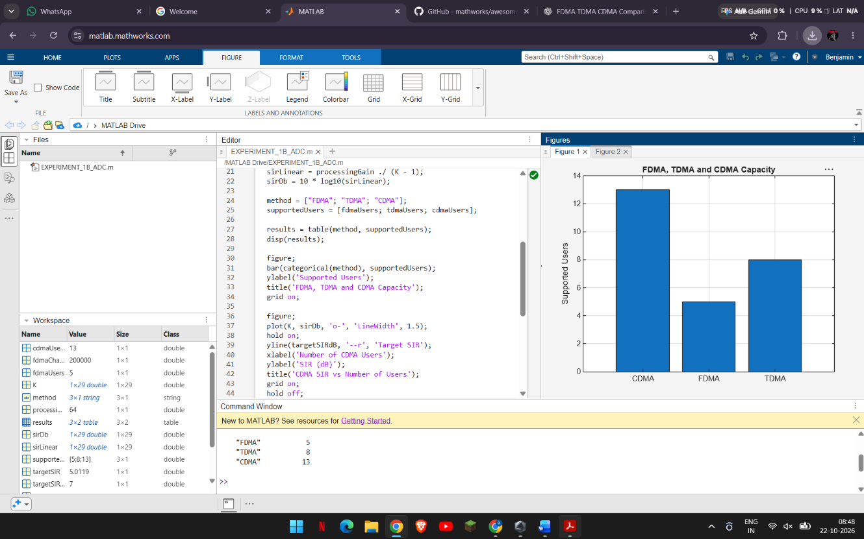

Output (CDMA SIR versus number of users):

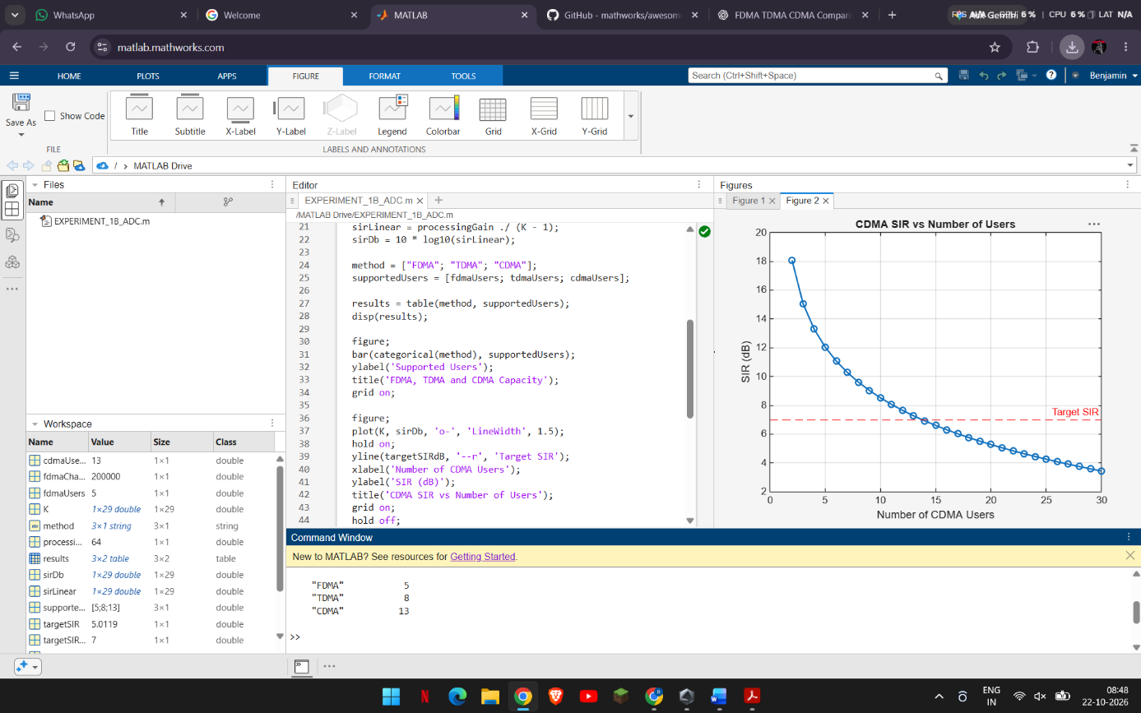

OBJECTIVE 3: Mobile-generation comparison
generation = ["1G"; "2G"; "2G"; "3G"; "4G"; "5G"];
system = ["AMPS"; "GSM"; "IS-95"; "UMTS"; "LTE"; "5G NR"];
accessMethod = ["FDMA"; "TDMA"; "CDMA"; "WCDMA"; "OFDMA"; "OFDMA-based"];
keyIdea = ["Separate frequency channels"; ...
"Separate time slots"; ...
"Code-based user separation"; ...
"Wideband code-based access"; ...
"Orthogonal frequency resources"; ...
"Flexible OFDM-based radio access"];

evolutionTable = table(generation, system, accessMethod, keyIdea);
disp(evolutionTable);
OUTPUT:
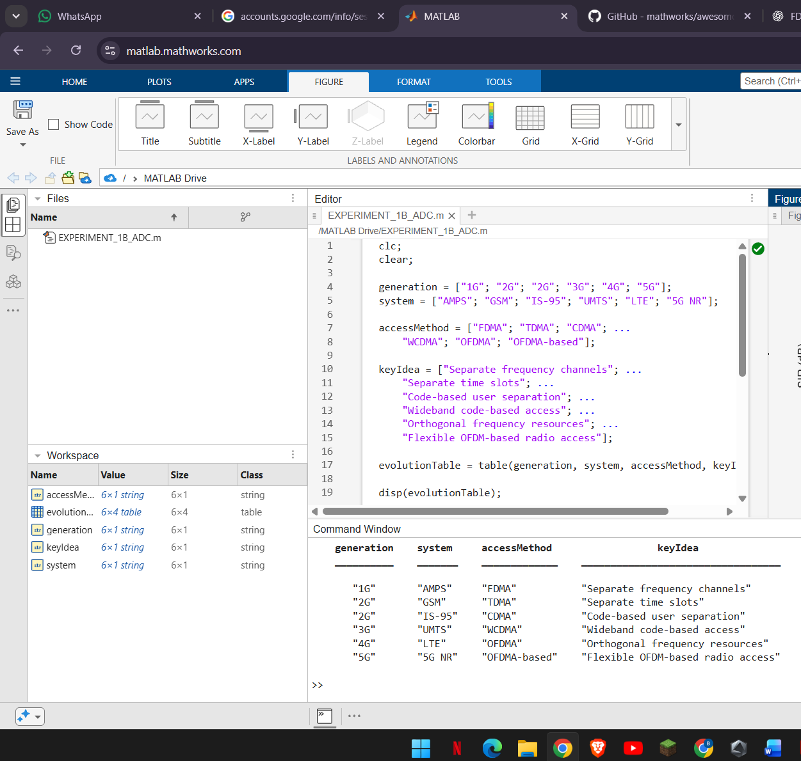

OBJECTIVE 4: Resource-allocation diagrams
figure;
tiledlayout(1,3);
% FDMA: users occupy different frequency channels
nexttile;
hold on;
colors = lines(4);
for u = 1:4
rectangle('Position',[0, u-1, 1, 0.8], ...
'FaceColor',colors(u,:), 'EdgeColor','k');
text(0.5, u-0.6, sprintf('User %d',u), ...
'HorizontalAlignment','center');
end
xlim([0 1]); ylim([0 4]);
xlabel('Time');
ylabel('Frequency channel');
title('FDMA');
set(gca,'YTick',[]);
hold off;

% TDMA: users occupy different time slots on one frequency channel
nexttile;
hold on;
for u = 1:4
rectangle('Position',[u-1, 0, 0.8, 1], ...
'FaceColor',colors(u,:), 'EdgeColor','k');
text(u-0.6, 0.5, sprintf('User %d',u), ...
'HorizontalAlignment','center');
end
xlim([0 4]); ylim([0 1]);
xlabel('Time slot');
ylabel('Frequency channel');
title('TDMA');
set(gca,'YTick',[]);
hold off;

% CDMA: users share the same time and frequency band using different codes
nexttile;
hold on;
for u = 1:4
rectangle('Position',[0, 0, 1, 1], ...
'FaceColor',colors(u,:), 'FaceAlpha',0.22, ...
'EdgeColor',colors(u,:), 'LineWidth',1.5);
end
text(0.5, 0.62, 'Users 1-4 share', 'HorizontalAlignment','center');
text(0.5, 0.40, 'band; different codes', 'HorizontalAlignment','center');
xlim([0 1]); ylim([0 1]);
xlabel('Time');
ylabel('Frequency band');
title('CDMA');
set(gca,'YTick',[]);
hold off;
sgtitle('Conceptual Time-Frequency Resource Allocation');
Output :
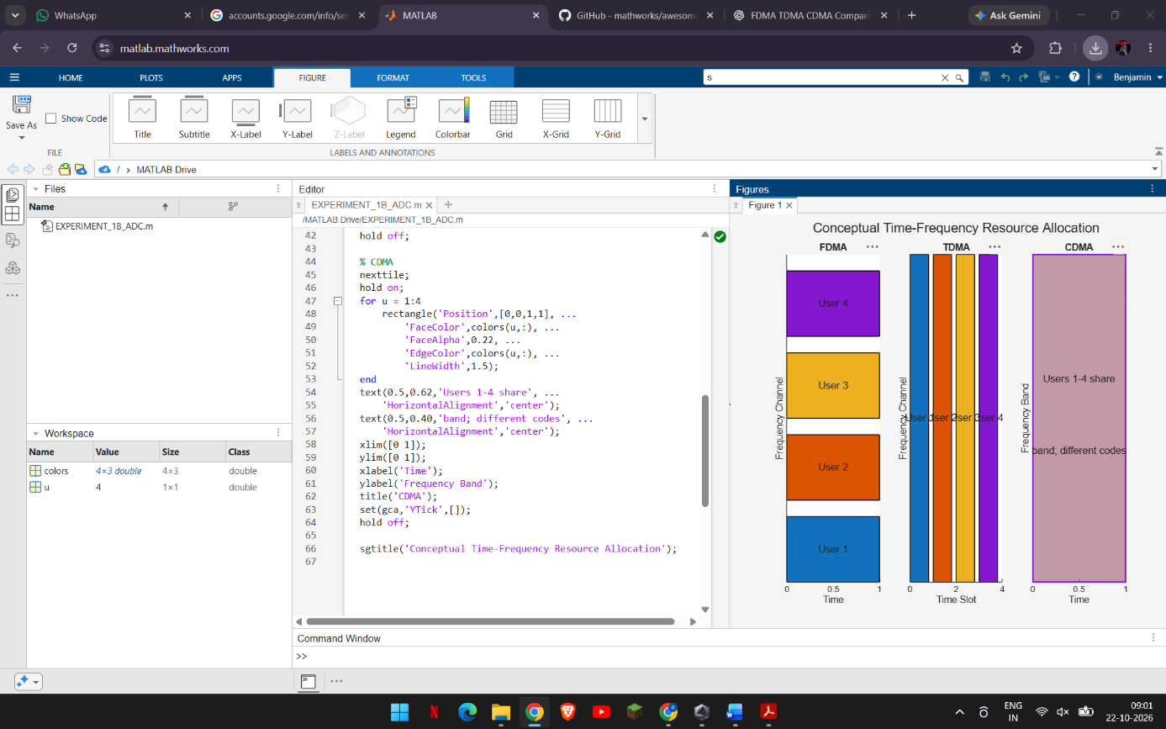

Conclusion:

The MATLAB programs demonstrate how FDMA, TDMA and CDMA allocate communication resources and how the assumed parameters affect their estimated user capacity. The CDMA analysis shows that estimated SIR decreases as more users share the same frequency band. The mobile-generation table and resource-allocation diagrams connect these techniques to the development of wireless communication systems. These results are based on simplified assumptions: the model assumes ideal FDMA and TDMA separation and does not include fading, power control, adjacent-channel interference or guard intervals. Therefore, the results illustrate the operating principles; they should not be treated as a universal performance ranking of the three methods.

